IMPORTANT NOTES:
Alfred Sung’s size chart reflects a body measurement, NOT a dress measurement
RUSH Fee - $40/Dress
Extra Length 5" - $30/Dress
Size 18W-30W - $30/Dress
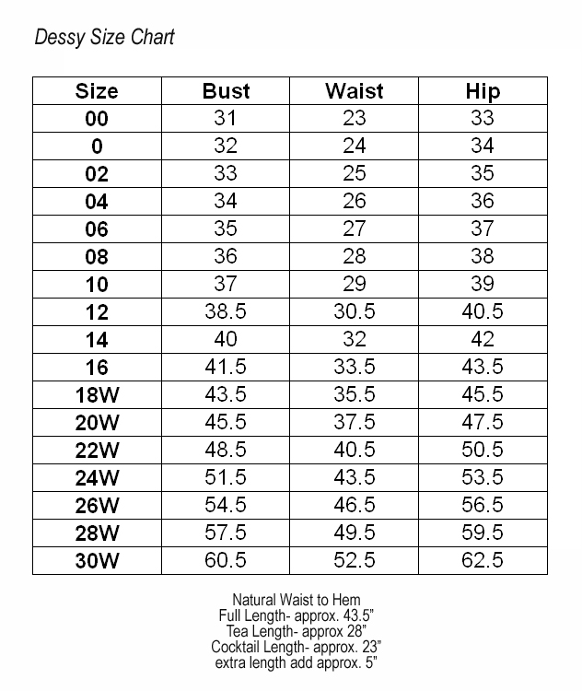
Updated 5.2016

